Definitions
RotoLock Mechanism
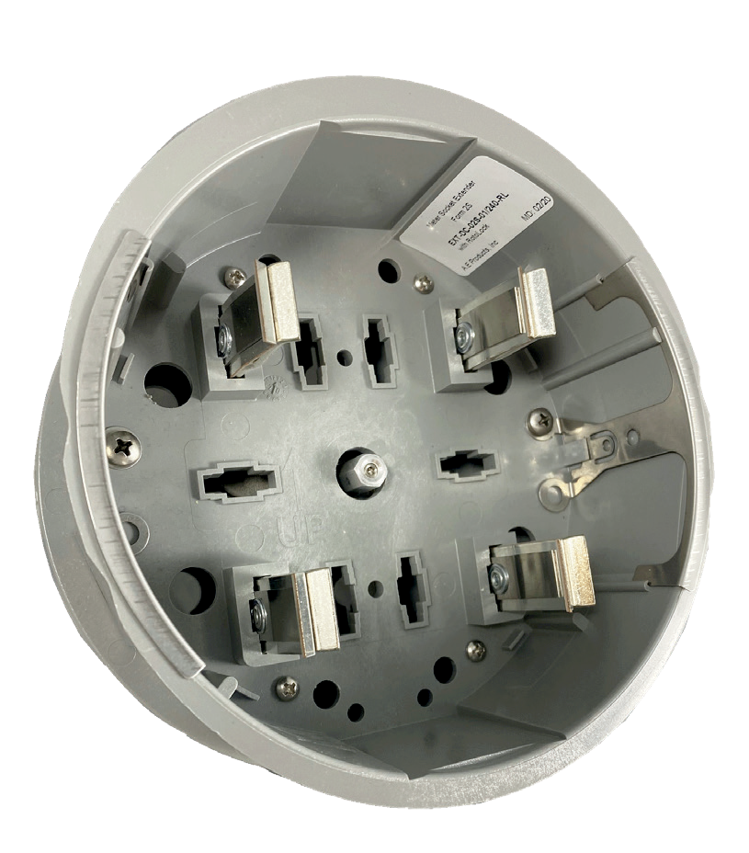Our unique RotoLock Mechanism feature can be incorporated into many of our products. The RotoLock Mechanism allows a housing or adapter to be attached to the front cover of a ring style or ringless meter socket, without the need to remove the cover by turning a centrally located activator. Once the electric meter is installed, the activator becomes inaccessible.

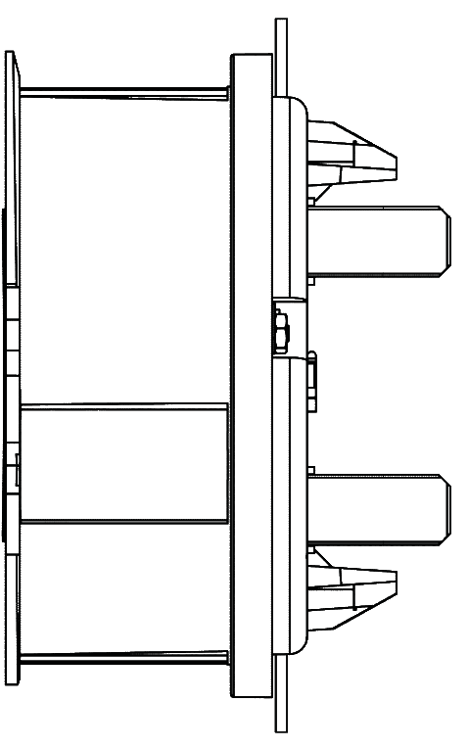200 AMP
Ringless Style
Meter Socket

Activator
Head Unit/ Meter Socket Adapter

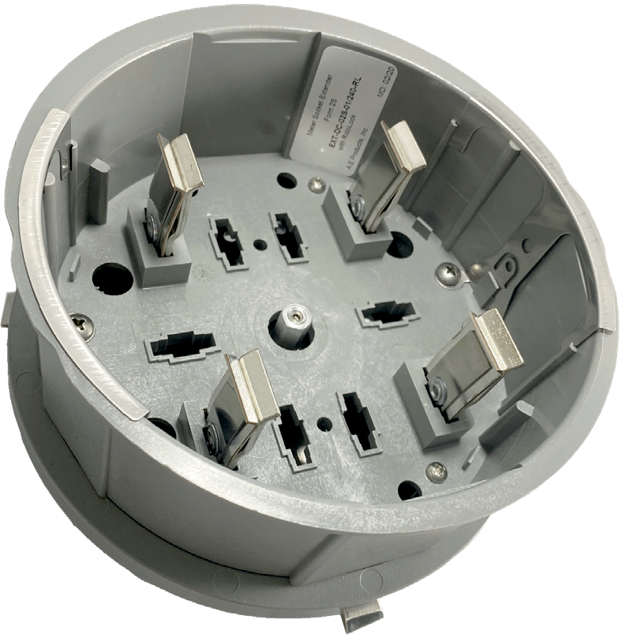Lock Bars
(3 Locations)
Lock bar extended

6
www.aeproducts.net

